1. Download two ultrasound images and two mammogram images from the ‘imaging modalities’ provided in Lecture 1 slides . Once you download them use the MATLAB function “imread” to read them into the matrices ‘im1,im2,im3,im4’ in MATLAB



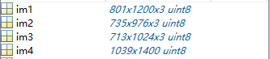

2. Use the ‘size’ MATLAB function to determine the size of your image. Both types of images are black and white and two dimensional not three dimensional like color images e.g. s = size(im1)

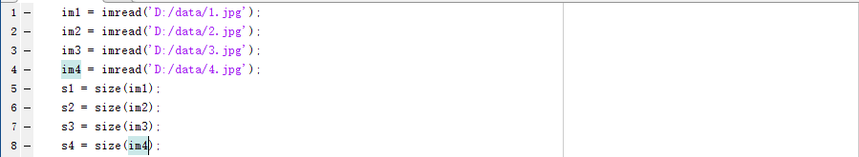

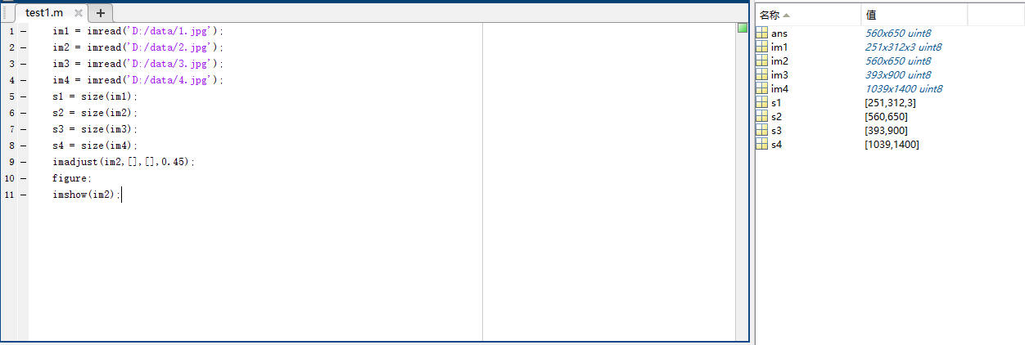

3. Learn how to use imadjust(f,[low_in,high_in],[low_out,high_out],gamma) to modify ultrasound images from the web, use values of 0.45 and 2.2 for gamma and compare the resulting images

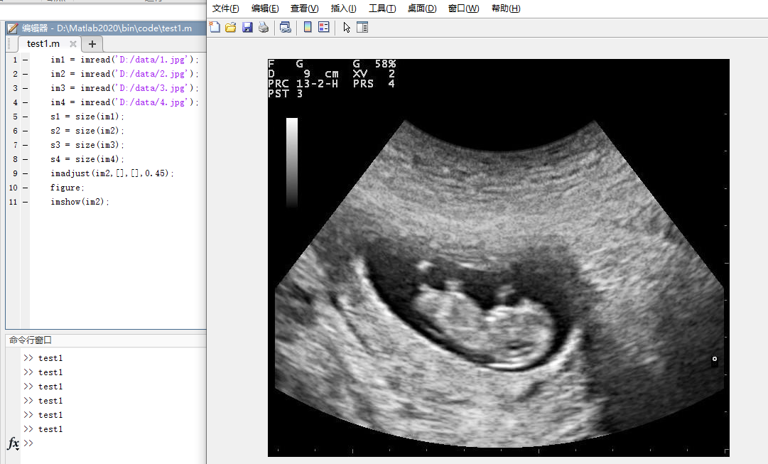



4. Use imadjust(f,[0,1],[1,0]) to invert a mammogram image and examine the result.

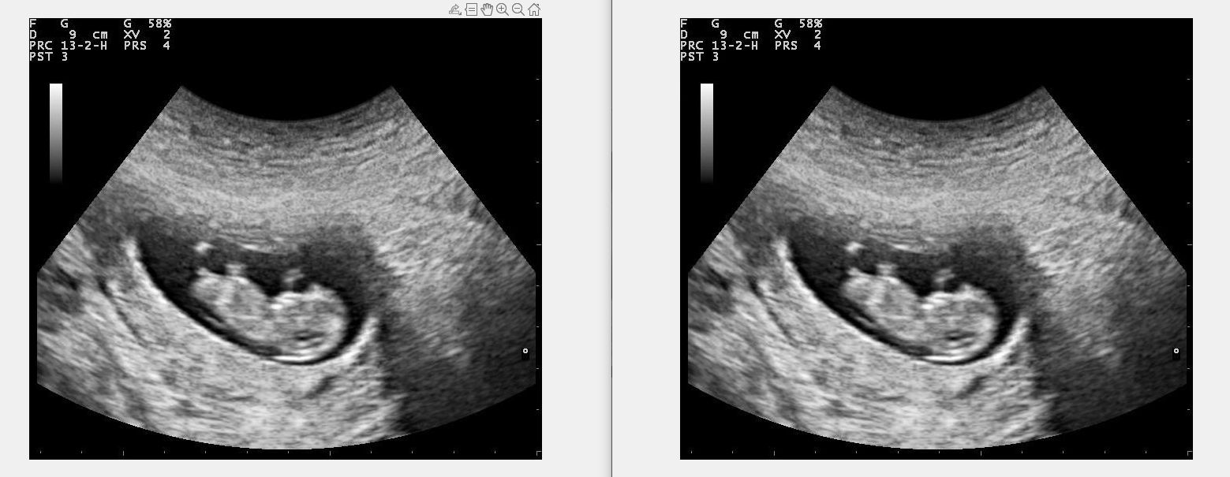

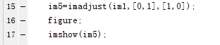

1. Learn how to use the Matlab function ‘mat2gray’ to scale image values to [0,1]

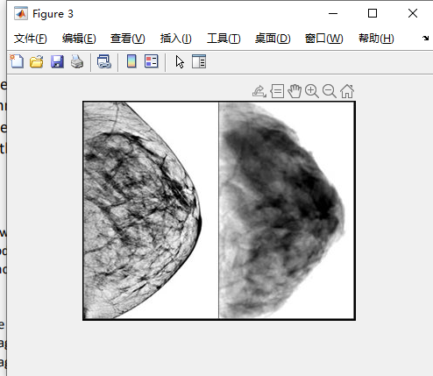



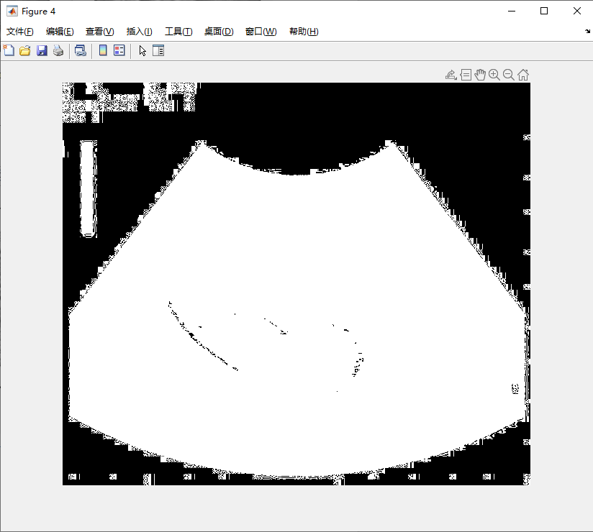

2. Learn how to use ‘im2uint8’ to convert the image to [0,255]

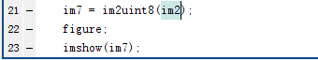





3. Take an aribitrary image from the web and convert it [0,1] and use G = c*log(1+double(f)) 0<f

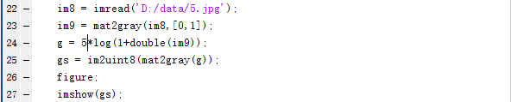

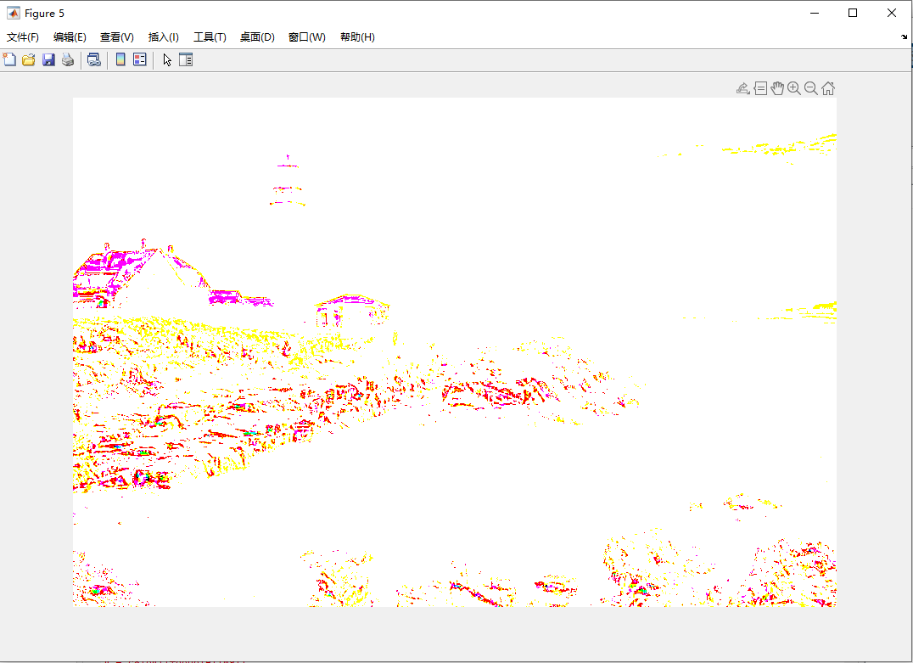

4. Use ‘imresize’ to up and down sample images from the web



